
Department of Artificial Intelligence and Data Science, VIIT
2025-2026

PBL Report
On
StudySync - Collaborative Study Tool

Subject: Human Computer Interaction
By

NAME | Roll No. | PRN | Email
Shadan Anwar | 371057 | 22210072 | shadan.22210072@viit.ac.in
Rakshit Shah | 371058 | 22210035 | rakshit.22210035@viit.ac.in
Vivek Ranalkar | 371067 | 22210197 | vivek.22210197@viit.ac.in

1. Introduction
In modern academic environments, students rely on multiple digital tools such as messaging platforms, document editors, and learning management systems to collaborate. This fragmented ecosystem leads to inefficiencies, lack of coordination, and increased cognitive load.
The Collaborative Study Tool is a web-based groupware system designed to unify these functionalities into a single platform. It integrates real-time communication, task management, file sharing, and activity tracking to support effective collaboration among students.
The system is built using a lightweight and efficient technology stack, focusing on usability, responsiveness, and simplicity. It leverages WebSocket-based communication to enable real-time interaction and provides both synchronous and asynchronous collaboration capabilities.

2. Problem Statement
Students currently face several challenges in group collaboration:
- Fragmented Tools: Switching between multiple platforms (e.g., messaging apps, Google Docs, LMS)
- Lack of Task Visibility: No structured tracking of group assignments
- Cognitive Overload: Managing multiple tools reduces focus and productivity
- Poor Coordination: No shared real-time workspace
These challenges result in miscommunication, missed deadlines, and inefficient teamwork.

3. Objectives
The primary objectives of the system are:
- To design a unified collaboration platform for students
- To enable real-time communication using WebSockets
- To provide a Kanban-based task management system
- To facilitate file sharing and resource management
- To track user contributions through activity analytics
- To ensure usability and accessibility through proper HCI principles

4. Scope of the System
The system is intended for:
- Student study groups
- Academic project teams
- Collaborative learning environments
In-Scope Features
- Room-based collaboration
- Real-time messaging
- Task management
- File sharing
- Activity tracking
Out-of-Scope Features
- Video conferencing
- Advanced AI-based recommendations (optional extension)
- Third-party integrations

5. System Overview
The Collaborative Study Tool is a client-server application with real-time capabilities.
Key Features
- Study Rooms
  - Users can create or join rooms
  - Role-based access (Admin, Member)
- Real-Time Chat
  - Instant messaging using WebSockets
  - Supports group discussions
- Task Board
  - Kanban-style workflow
  - Tasks categorized into:
    - To-Do
    - In Progress
    - Done
- File Sharing
  - Upload and download documents
  - Centralized resource access
- Activity Tracking
  - Tracks user participation
  - Displays contribution statistics
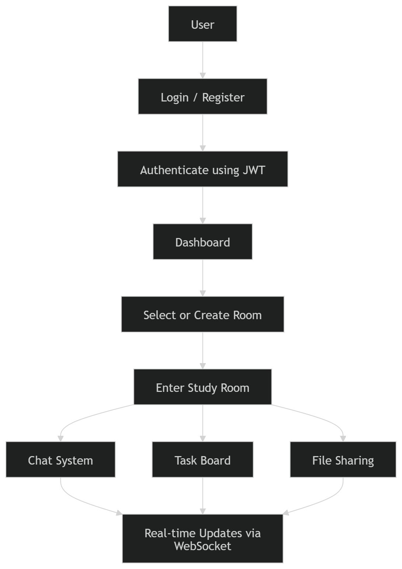

6. Technology Stack
Layer | Technology | Justification
Backend | FastAPI | High performance, async support
Database | SQLite → PostgreSQL | Easy development, scalable upgrade
Auth | JWT | Stateless and secure
Frontend | HTML + Tailwind + JS | Lightweight, no build complexity
Real-time | WebSockets | Low latency communication
Storage | Local Disk | Simplicity
The chosen stack ensures low complexity, high performance, and ease of deployment .

7. System Architecture
The system follows a three-tier architecture:
7.1 Presentation Layer (Frontend)
- Built using Tailwind CSS and JavaScript
- Handles user interaction and UI rendering
- Communicates with backend via HTTP and WebSockets
7.2 Application Layer (Backend)
- FastAPI-based REST services
- Handles business logic
- Manages authentication and data processing
7.3 Data Layer (Database)
- Stores structured data
- Ensures data consistency and integrity

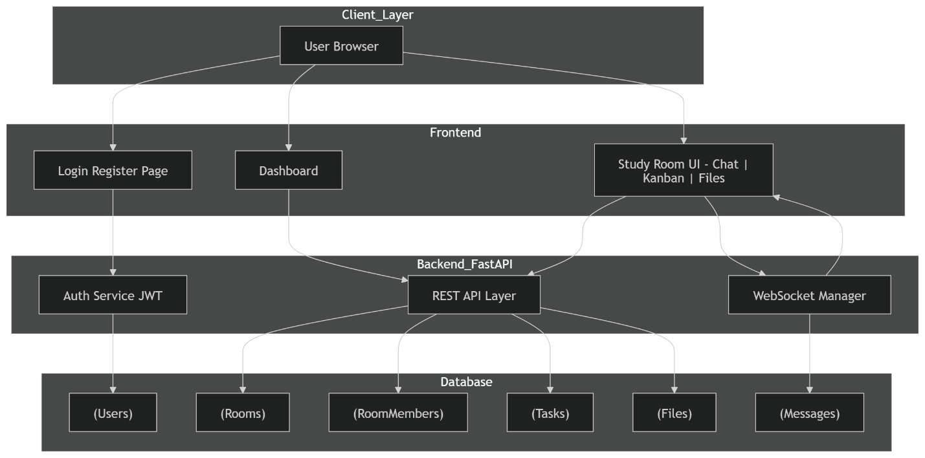
Communication Flow
- REST APIs for CRUD operations
- WebSockets for real-time updates

8. Database Design
The database is normalized and consists of the following tables:
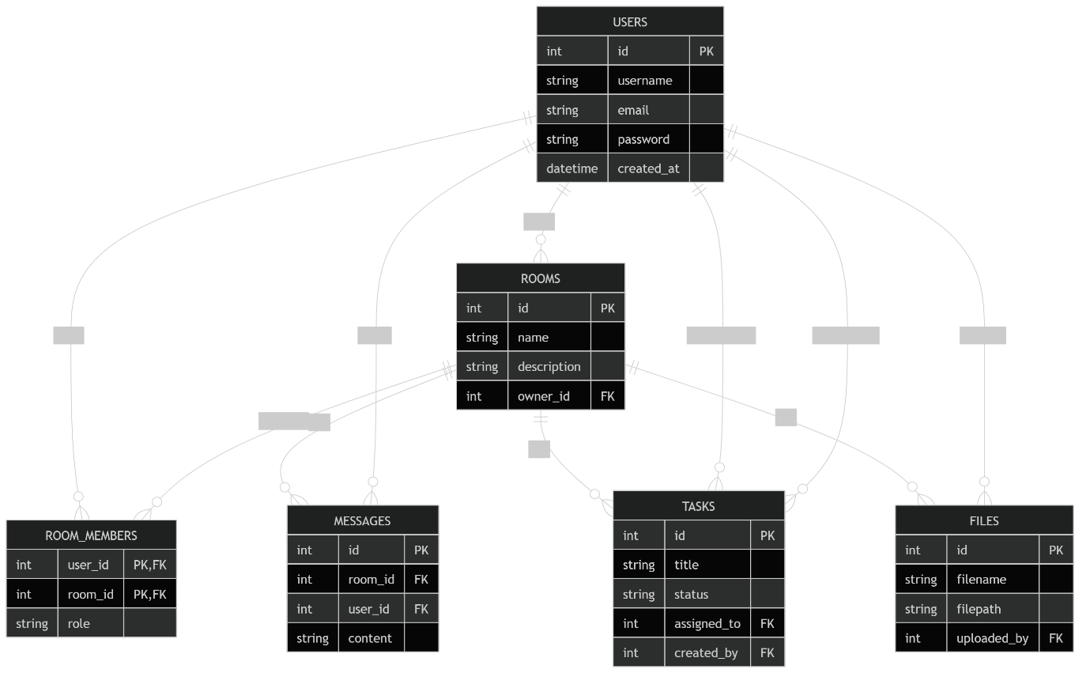
This schema ensures modularity, scalability, and efficient querying .

9. Functional Modules
9.1 Authentication System
- Secure login and registration
- JWT-based session management
- Password hashing for security
9.2 Room Management
- Create and join rooms
- Manage participants and roles
9.3 Task Management System
- Create, update, and delete tasks
- Assign tasks to members
- Drag-and-drop Kanban board
9.4 Real-Time Chat System
- WebSocket-based communication
- Instant message broadcasting
9.5 File Management System
- Upload and download files
- Centralized document storage
9.6 Activity Monitoring
- Tracks:
  - Number of messages sent
  - Tasks completed
- Provides performance insights

10. API Design
REST APIs
- Authentication endpoints
- Room and task management
- File operations
WebSocket API
- Single connection per room
- Handles:
  - Chat messages
  - Task updates
This hybrid approach improves efficiency and responsiveness .

11. Frontend Design
The UI is divided into three screens:
- Login Page
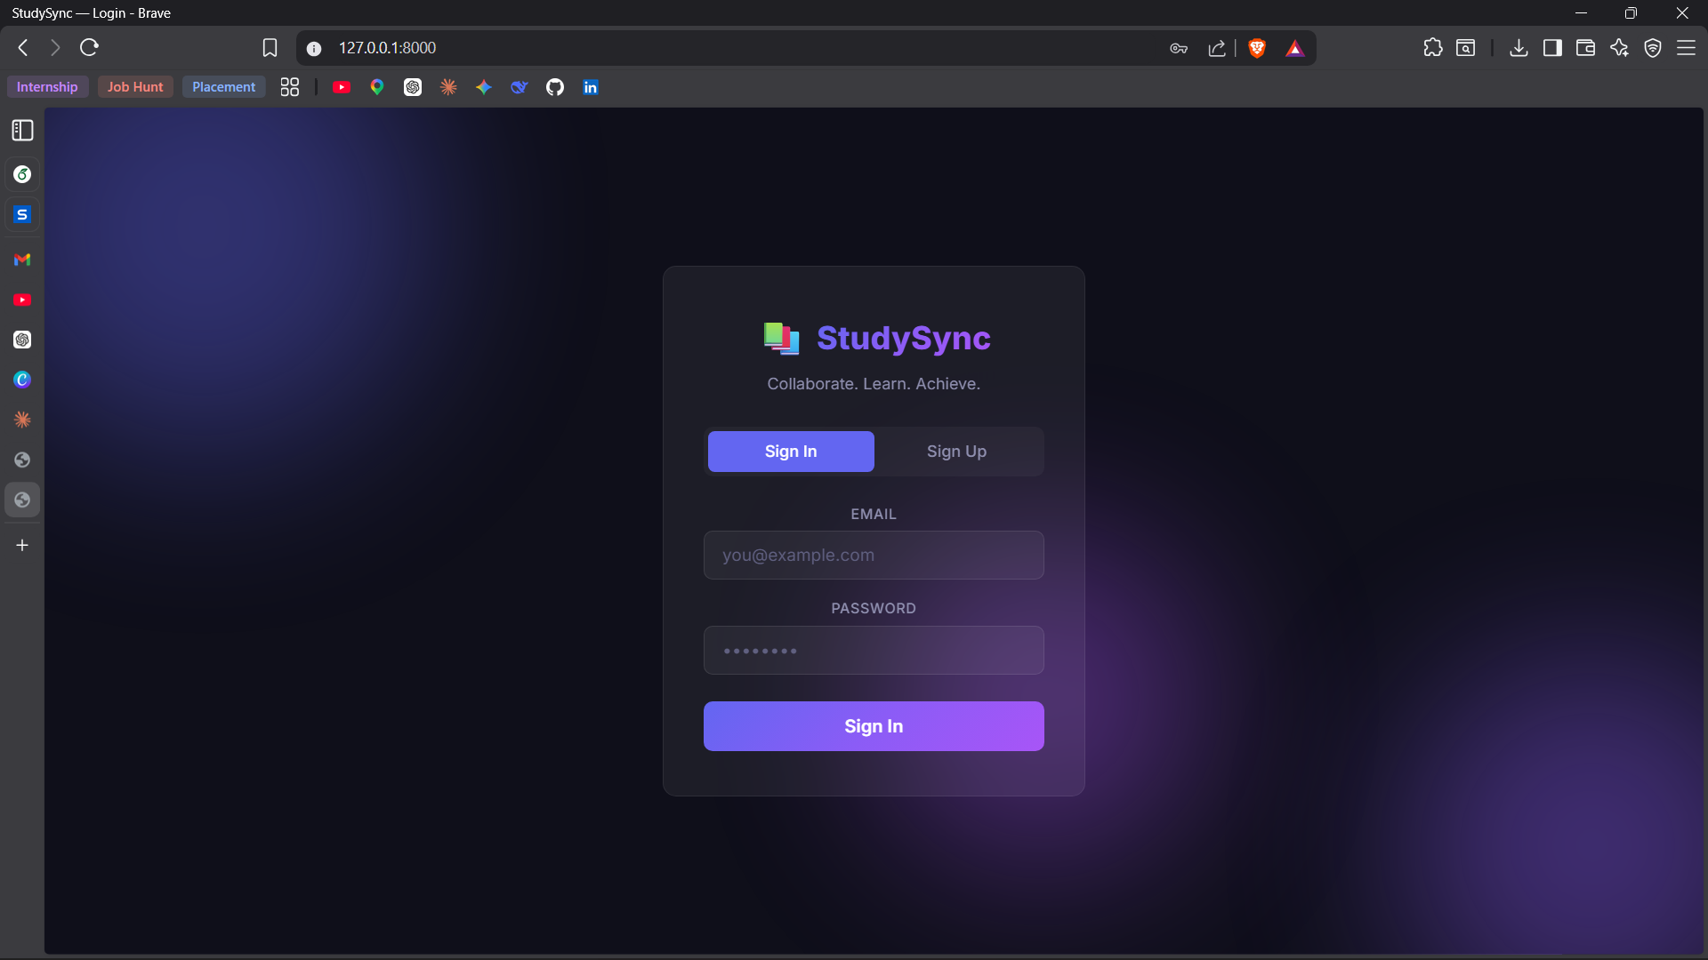
- Minimal interface
- User authentication

2. Dashboard
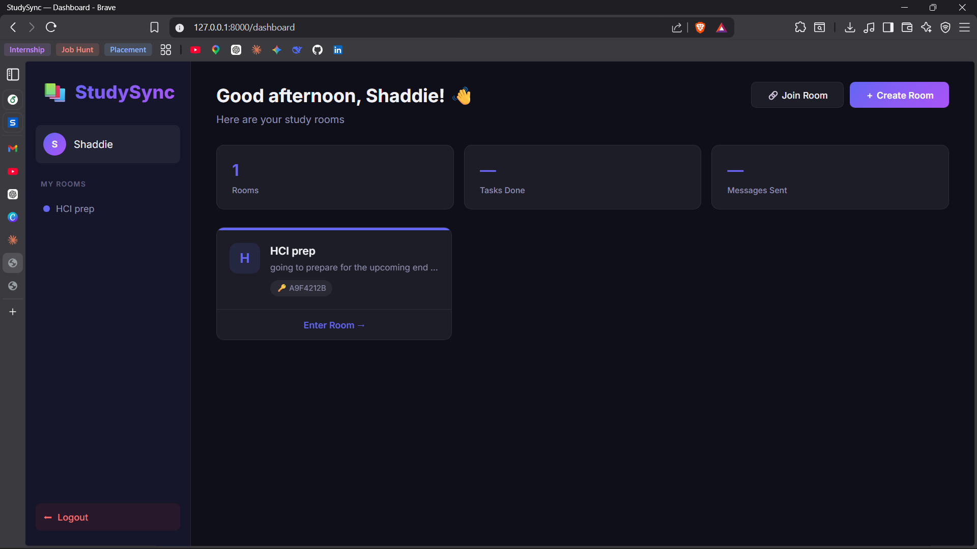

- Displays rooms
- Create/join options
3. Study Room
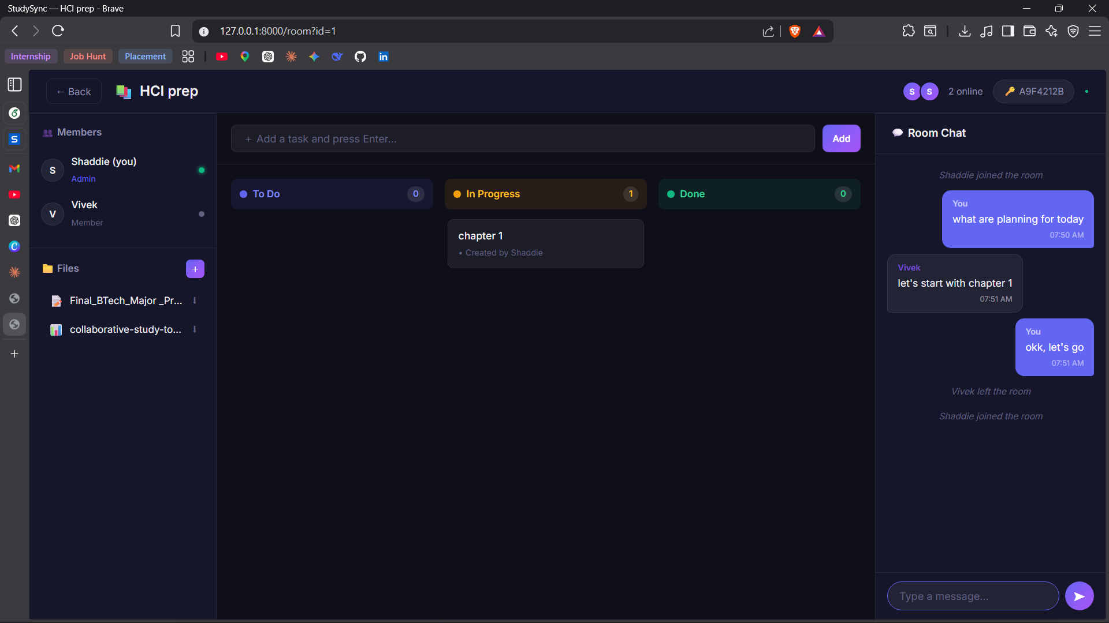

- Three-panel layout:
  - Left: Members & files
  - Center: Task board
  - Right: Chat
The design emphasizes:
- Simplicity
- Consistency
- Ease of navigation

12. Human-Computer Interaction (HCI) Principles
The system incorporates key HCI concepts:
1. Gulf of Execution
- Clear actions like “Create Room” and “Add Task”
2. Gulf of Evaluation
- Immediate feedback (task updates, chat delivery)
3. Eight Golden Rules
- Consistency in UI
- Error prevention
- Feedback mechanisms
4. Norman’s Action Model
- Users can easily:
  - Form goals
  - Execute actions
  - Evaluate outcomes
5. Interaction Styles
- Direct manipulation (drag-and-drop)
- Menu selection
- Form input

13. Real-Time Communication
WebSockets enable:
- Persistent connection
- Low latency (<100ms)
- Instant updates
Advantages Over HTTP
- No repeated requests
- Server push capability
- Efficient data transfer

14. Evaluation Plan
Heuristic Evaluation
- Visibility of system status
- Error prevention
- Consistency
Usability Testing
- Participants: 5–10 students
- Tasks:
  - Create room
  - Assign task
  - Upload file
Metrics
- Learnability
- Efficiency
- Error rate
- User satisfaction

15. Implementation Plan
The system is developed in phases:
- Backend setup
- API development
- WebSocket integration
- Frontend development
- Feature integration
- Testing
This phased approach ensures structured development .

16. Design Decisions
- Avoid React to reduce complexity
- Use SQLite for quick setup
- Use single WebSocket connection per room
- Store files locally
- Use Tailwind CDN
These decisions optimize development speed and maintainability.

17. Advantages of the System
- Unified collaboration platform
- Real-time communication
- Improved productivity
- Reduced cognitive load
- Easy to use and deploy

18. Limitations
- No video conferencing
- Limited scalability with local storage
- Basic UI compared to enterprise tools

19. Future Enhancements
- AI-based task suggestions
- Chat summarization
- Dark mode
- Cloud storage integration
- Mobile application

20. Conclusion
The Collaborative Study Tool successfully addresses the limitations of fragmented collaboration systems by providing a unified, real-time platform. It enhances coordination, improves task visibility, and reduces cognitive load.
By combining FastAPI, WebSockets, and a clean UI, the system delivers both performance and usability. It demonstrates the effectiveness of groupware systems in improving academic collaboration and serves as a strong foundation for future enhancements.

21. References
Books / HCI Foundations
- Designing the User Interface — Ben Shneiderman et al.
- The Design of Everyday Things — Don Norman
- Interaction Design: Beyond Human-Computer Interaction

